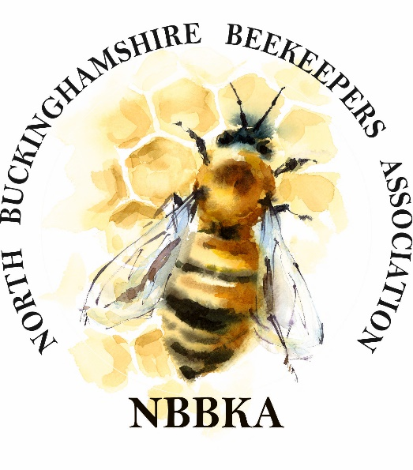
North Buckinghamshire Beekeeping Association
Open Honey Show
On
Sunday 24th September 2023
At

York House, Stony Stratford, Milton Keynes MK11 1JQ

ENTRY FORM v4

Name: .............................................................................................................................................................
Address: ........................................................................................................................................................
.........................................................................................................................................................................
Postcode: ....................................................... Phone: ...............................................................................
Email: ....................................................................... Mobile phone number: …………………………….
Are you a member of NBBKA? Yes/No Novice? Yes/No Junior/Student? Yes/No
Data Protection: Please sign here if you agree for your name and photo to be used in NBBKA
website and social media updates and on any trophy you may win …………………………………
Are you entering for the open classes? Yes/No
Note: Only members of NBBKA can enter classes 1 to 33.
Please return your completed form to: Rachael Hulme NBBKA Honey Show Secretary. 46 Tudor Gardens, Stony Stratford MK11 1HX or scan and email to: honeyshow@nbbka.org by WEDNESDAY 20TH September 2023

Please mark in the box which classes you do intend to enter and confirm how many entries you wish to make in each class. (Please note, there is no penalty for not presenting entries on the day of the show). If you submit more than one entry only the best placed can win a prize, only one prize per person per class.

Entries will be accepted from 8.30am until 10.30am on the morning of the 24th September. Judging will start promptly at 11am, no entries can be accepted after 10.45am.

CLASS | DESCRIPTION | TOTAL NUMBER OF ENTRIES
1 | Two Jars Light Honey
2 | Two jars Medium Honey
3 | Two Jars Dark Honey
4 | Two jars of naturally set honey
5 | Two jars soft set/creamed honey
6 | Two matching jars Chunk Honey
7 | One piece cut comb (225g – 8oz) judged on appearance only
8 | One standard comb of honey suitable for extraction
9 | Gift. One jar of any honey of any size or type
10 | Six matching jars honey labelled for sale
11 | One Section of honeycomb, round or square
12 | One jar of honey, wrapped, judged on taste and aroma
13 | One cake of Beeswax 200-255g (7-9oz)
14 | Five matching pieces beeswax each 28g (1oz)
15 | Three matching candles, dipped or moulded
16 | Three matching candles, rolled
17 | Honey Fruit cake
18 | Plain Honey Cake
19 | Honey Fudge
20 | One bottle Dry Mead
21 | One bottle Sweet Mead
22 | One bottle Honey Wine
23 | Craft item
24 | Photograph -
25 | Novice: One 1lb jar runny honey
26 | Novice: One 1lb jar of crystallised or soft set honey
27 | Novice: One piece beeswax 110g-170g (4-6oz)
30 | Composite Class
31 | Shop Display
32 | Honey Label (on empty 1lb honey jar) for legal sale in UK
33 | Microscope Slide prepared by the exhibitor. 3” x 1”, subject pollen or honeybee anatomy
 | CHILDRENS CLASSES (U16’s)
28 | Craft Item – One item made by the exhibitor, cake, drawing or photograph (see honey show rules for details)
29 | 1 jar of honey, light honey. To be judged on taste, smell, clarity and texture.
34 | THIS CLASS IS OPEN TO CHILDREN IN MK  This entry must be submitted by Wednesday 20th September to Honey Show Secretary. Photography – 1 photograph bee related mounted on an A4 card.
OPEN CLASSES
(Open to all associations)
50 | Two matching (1lb) jars of light clear honey.
51 | Two Matching (1lb) jars of medium clear honey
52 | One (1lb) jar of honey which will be judged on aroma and flavour alone. The honey can be unfiltered and must be wrapped in silver foil (provided by the honey show secretary)
53 | Honey cake – made using the recipe quoted on the NBBKA honey show rules, class 18.
54 | One cake of beeswax 200-255g (7-9oz)

NBBKA MEMBERS - IF YOU ARE FREE FROM 7.45AM ON THE MORNING OF THE HONEY SHOW, DURING THE DAY OR AT 4PM.
WE WOULD ALWAYS WELCOME YOUR HELP PLEASE!

